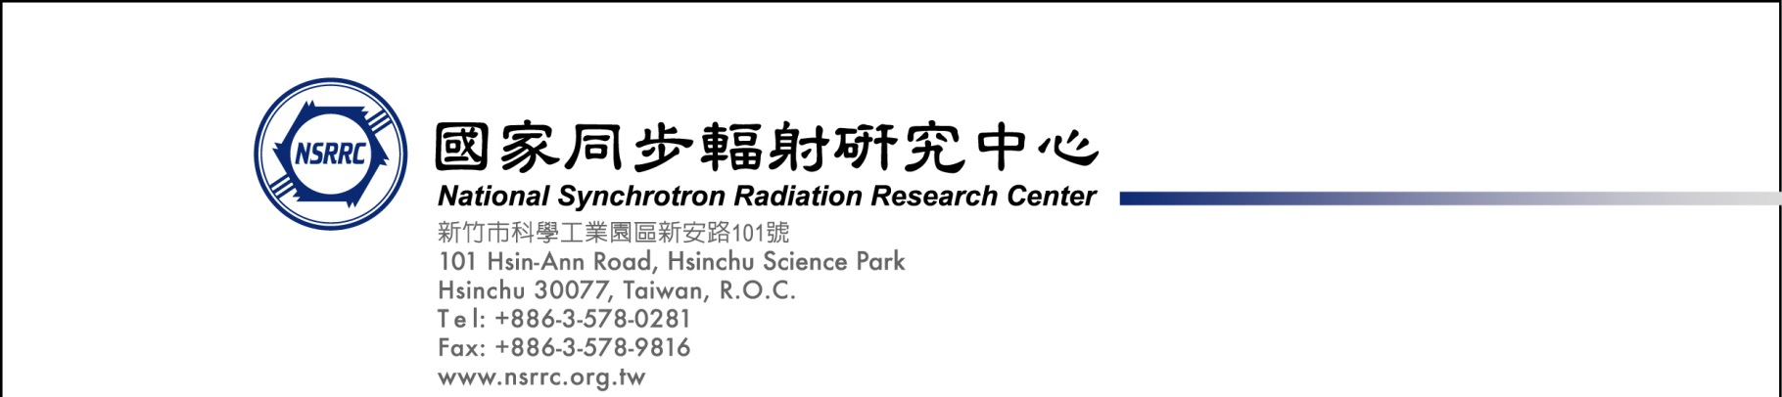
投標注意事項:
Bidding Documents Submission Notice:
廠商於投標前務必詳讀本案規格書及契約內容且須全部達到本案規格書及契約之要求，否則請勿投標
Tenderer(s) should carefully read and fully understand SRPO-1080568 specification and Terms and Conditions, and agrees to achieve all required specifications and Terms and Conditions. Otherwise, please do not attend this bidding.

- 請將外標封黏在快遞信封外如圖示。
Please paste our cover sheet on the outside of a forwarder’s envelope as below.
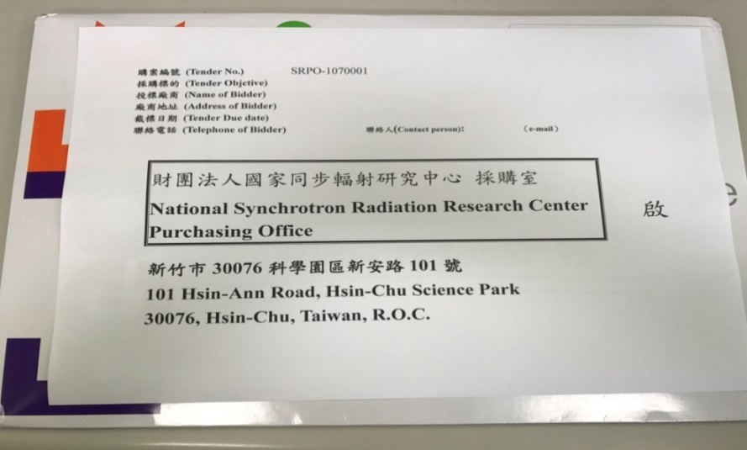

- 請將資格標封黏貼在信封外如圖示；
Please paste qualification sheet on the envelope as illustration below.
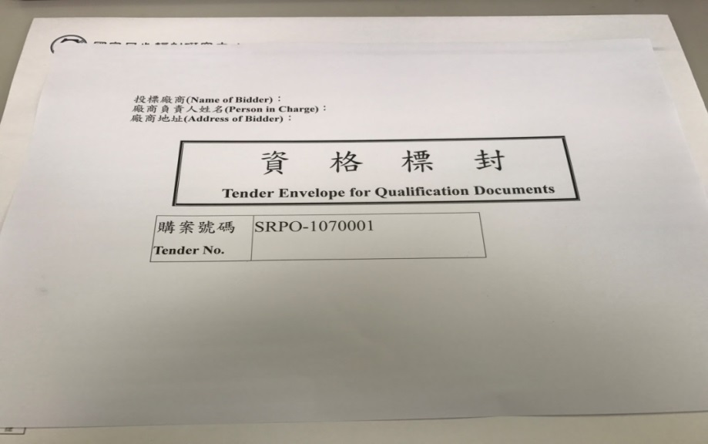
- 資格標封內請檢附以下文件:
This qualification envelope shall be enclosed with following document:
(1)設立登記證明
A copy of Certificate of registration or establishment documents under applicable law of their country.
Document aforementioned shall be translated into Chinese, and notarized or certified by notary public or ROC Overseas Mission. The tenderer(s) may refer to ROC Overseas Missions for document authentication service.
(2)投標廠商聲明書
Statement of Tenderer

(3)投標廠商代理人授權書
Power of Attorney signed by Company President or CEO

- 請將價格標封黏貼在信封外如圖示；
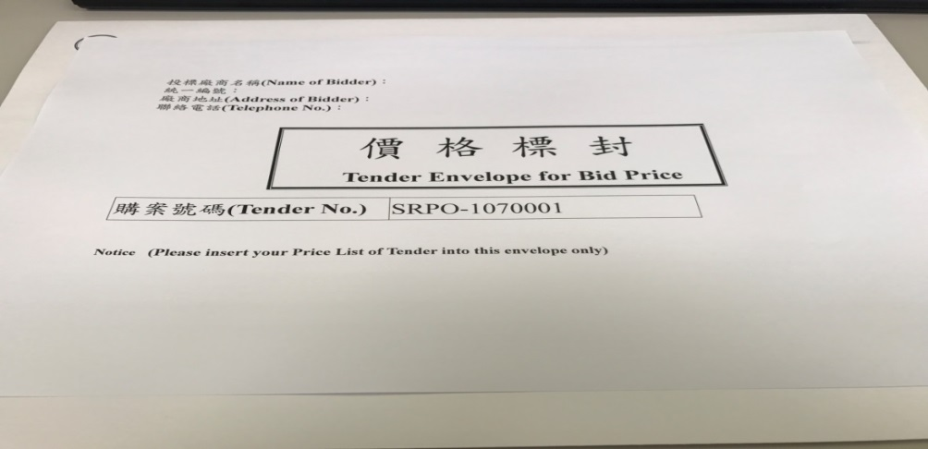
Please paste Bid Price sheet on the envelope as illustration below.

5.價格標封內請檢附以下文件:
This bid price envelope shall be enclosed with following document:
■用印之標價清單
A signed Price List of Tender with your Bid Price

6.彌封資格及價格標彌封後，請置於外標封並彌封。
After you have both qualification & bid price envelope sealed, please put them in the cover envelope and seal it up.

7.請於截標前將投標文件送達本中心。
Please submit your documents to NSRRC by closing deadline.

※ 請留意投標文件逾期將不予受理。
Please note a late tender will not be considered.

Kind regards,

Si-Ting, Wang
Procurement Office
Tel:+886-3-5780281 ext:8405
E-mail address: wang.siting@nsrrc.org.tw

